Smart Lender – Loan Eligibility Prediction System
Run the Application
Objective
The objective of this project is to develop a simple web application that predicts whether a loan application is approved or not. The application is built using Python Flask with HTML and CSS for the frontend.
Software Requirements
- Python 3.x
- Visual Studio Code
- Flask
- HTML
- CSS
- Web Browser (Chrome/Edge)
Project Structure
smart_lender/
│── app.py
│── requirements.txt
│── model/
│── static/
│ └── css/
│ └── style.css
└── templates/
├── home.html
├── predict.html
└── output.html
Implementation Steps
Step 1: Flask Application
Created the Flask application and defined the application routes.
app.py
from flask import Flask, render_template, request

app = Flask(__name__)

@app.route('/')
def home():
return render_template('home.html')

@app.route('/predict')
def predict():
return render_template('predict.html')

@app.route('/result', methods=['POST'])
def result():
return render_template('output.html', result="Loan Approved")

if __name__ == '__main__':
app.run(debug=True)

Step 2: Home Page
Created the Home page with a project title and navigation button.
home.html
<h1>Smart Lender</h1>
<p>Loan Approval Prediction System</p>

<a href="/predict">
<button>Predict Loan</button>
</a>

Step 3: Prediction Page
Created a simple prediction page containing a form.
predict.html
<form action="/result" method="POST">
<button type="submit">Predict</button>
</form>

Step 4: Output Page
Displayed the prediction result returned by Flask.
output.html
<h1>Loan Approval Prediction</h1>

<h2>{{ result }}</h2>

<a href="/">
<button>Go Back</button>
</a>

Step 5: CSS Styling
Designed the application using CSS.
style.css
body{
text-align:center;
background:#f2f2f2;
}

.container{
background:white;
width:450px;
margin:auto;
padding:30px;
border-radius:10px;
}

button{
padding:10px 20px;
background:#007BFF;
color:white;
}

Step 1: Create Project Folder
Created the Smart Lender project folder with the required subfolders (model, static, templates).
Step 2: Develop Application
Created the Flask application using app.py and designed the web pages using HTML and CSS.
Step 3: Install Dependencies
Installed Flask using the requirements file.
Command:
pip install -r requirements.txt
Step 4: Run the Application
Executed the application using:
python app.py
The application started successfully on:
http://127.0.0.1:5000
Step 5: Home Page
Successfully opened the Smart Lender home page.
Screenshot:
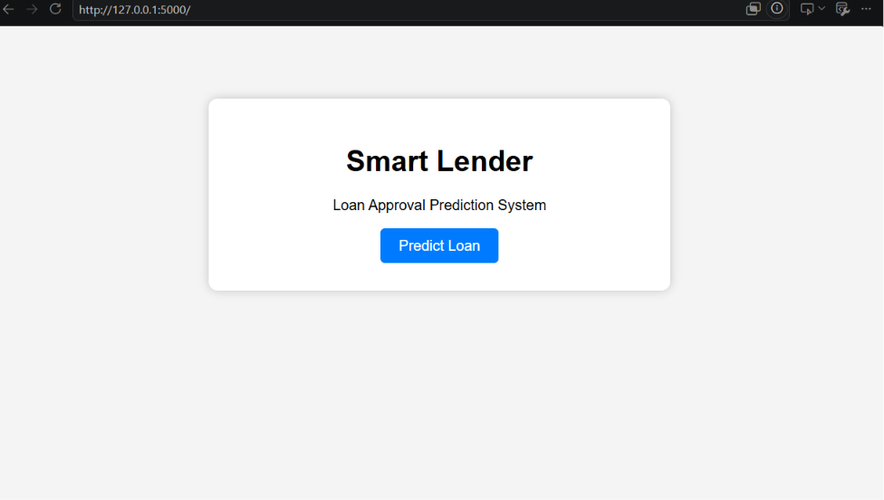
Step 6: Prediction Page
Opened the prediction page and tested the application.
Screenshot:
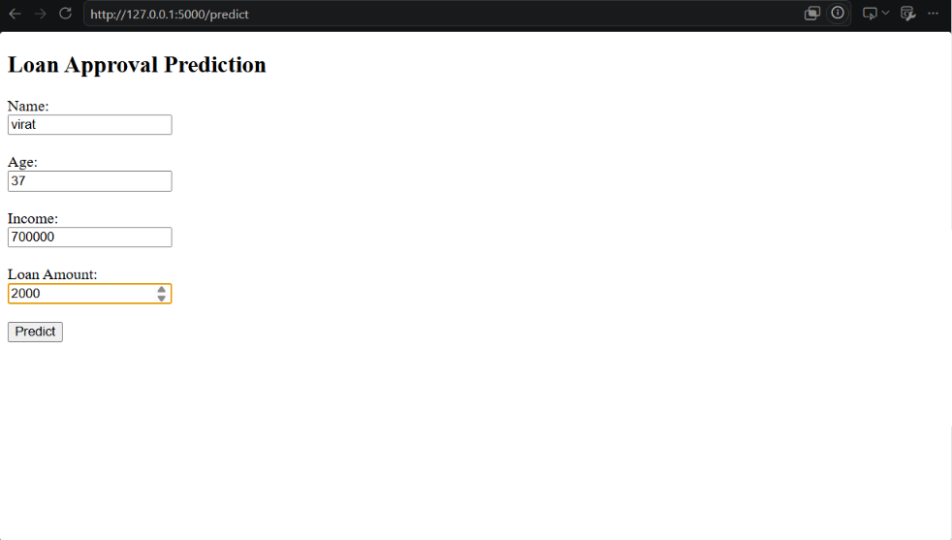
Step 7: Result Page
The application displayed the prediction result successfully.
Screenshot:
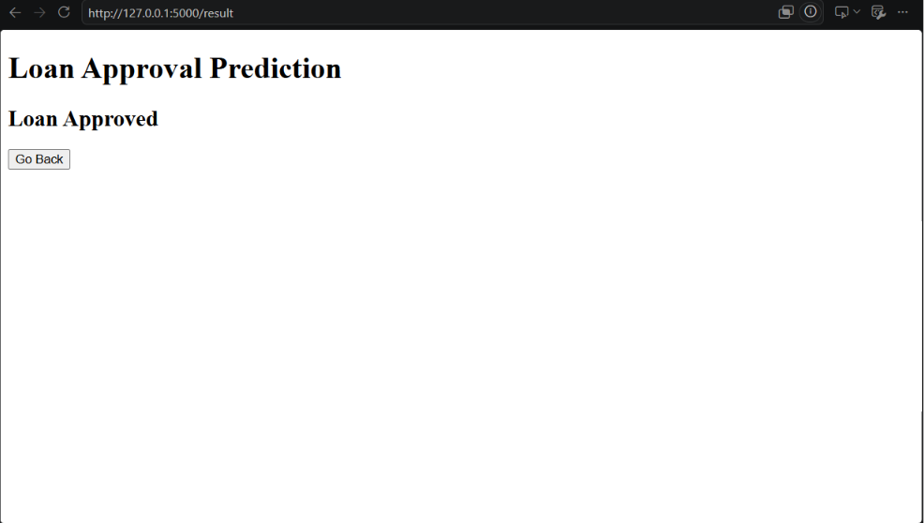
Result
The Smart Lender Loan Approval Prediction System was developed and executed successfully. The Flask application ran without errors, and all web pages (Home, Predict, and Result) were displayed correctly.
Conclusion
The Smart Lender project demonstrates the implementation of a basic Flask web application with HTML and CSS. It provides a simple workflow for loan approval prediction and helps understand Flask routing, templates, and frontend integration.

